Guide to the RDAQ
How to enter descriptions of
fonds and collections into the Réseau de diffusion des archives
du Québec (RDAQ) database

Table of contents

What is the Réseau de diffusion des archives du Québec? 1
How to access it. 2
How to register with the RDAQ. 3
How to sign in to the RDAQ. 4
How to enter descriptions. 6
How to enter a fonds-level description. 6
How to enter a lower-level description. 11
How to announce a virtual description. 13

What is the Réseau de diffusion des archives du Québec?
The Réseau de diffusion des archives du Québec (RDAQ) is a website produced by the Réseau des services d’archives du Québec (RAQ) in collaboration with Bibliothèque et Archives nationales du Québec (BAnQ). The primary objectives of the RDAQ are to reveal the rich heritage resources preserved in Québec’s archival centres, enable research in those resources, and facilitate their remote communication.
To these ends, the RDAQ seeks to pool descriptions of fonds and collections from all the archival services in Québec. It enables research in Québec’s archives and promotes virtual exhibits created by Québec archival services. Participating archival services should soon see their RDAQ descriptions periodically deposited in ArchivesCanada.ca, portal of the Canadian Archival Information Network, which will give them a showcase on the world.

How to access it.
The RDAQ is free. It enables archival services to place descriptions of their archives directly onto the Web without having to acquire a programme. You can access it at this address: www.rdaq.qc.ca
You will arrive at the site’s homepage:
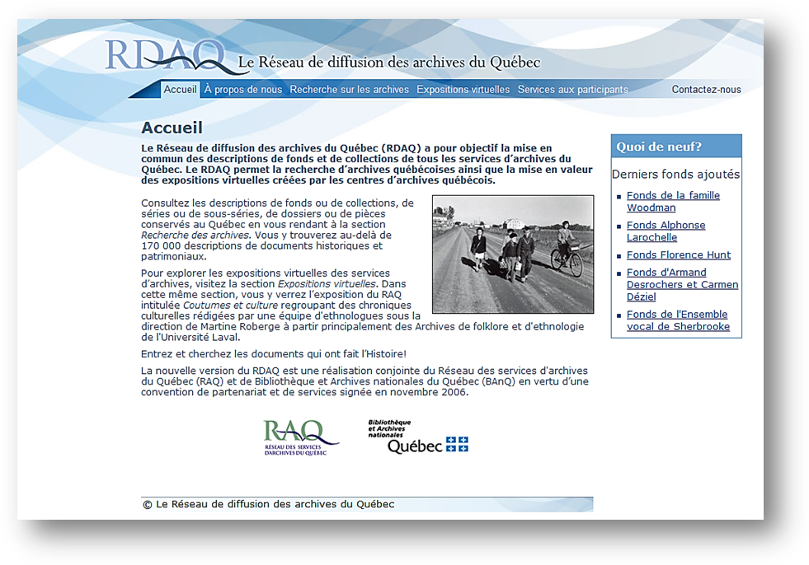

How to register with the RDAQ.
To enter descriptions into the RDAQ database, you must first register your archival service. On the site’s homepage, at the Services aux participants tab, click on Adhésion au RDAQ. You will arrive at the registration form, which you can then fill out.
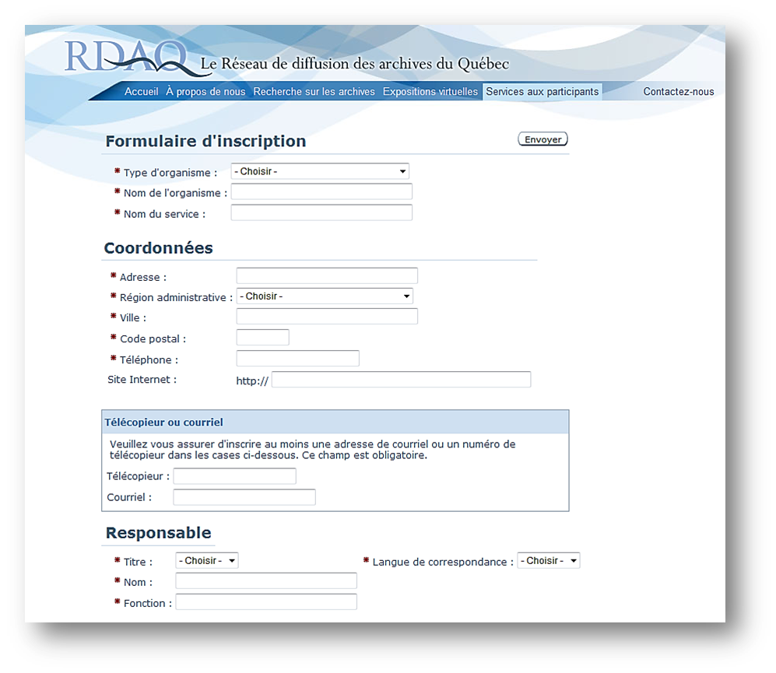
When you have completed this stage, click on Envoyer and the request for registration will be sent to the RDAQ website administrator. An e-mail message will then be sent to you containing your user name and password. The form contains the elements of presentation of your archival service. Your service will subsequently appear in the list of participating organizations with the information that you provided on the form.
How to sign in to the RDAQ.
After receiving your user name and password, you can sign in to the RDAQ. On the site’s homepage, at the Services aux participants tab, click on Connexion au RDAQ and you will arrive at this page:
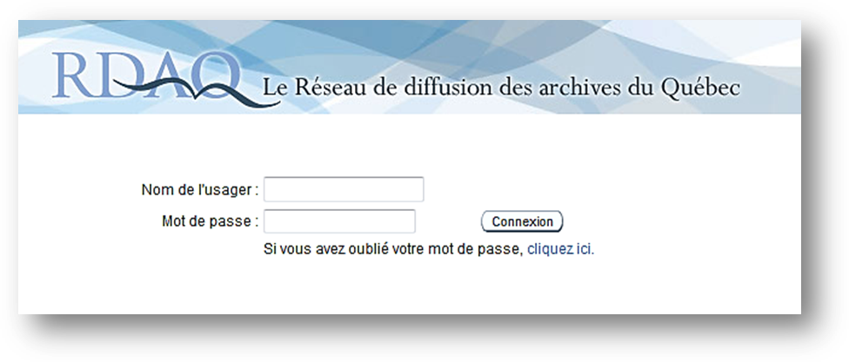
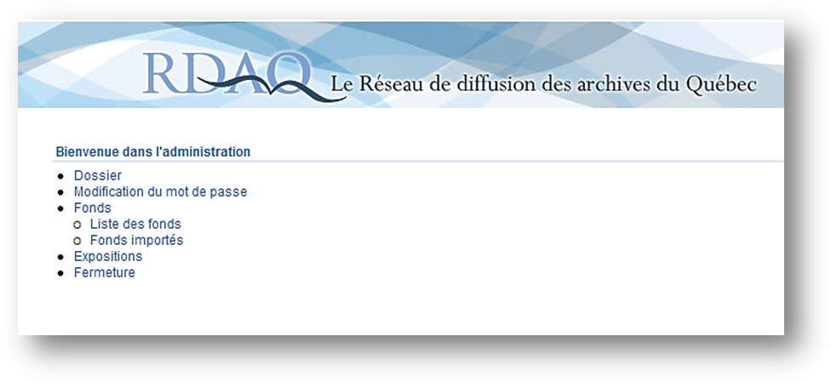
Enter your user name and password, and you will come to the page enabling the management of your account.
From the management page, you will be able to access several services. The Dossier allows you to modify the presentation of your archival service, its contact information, the name of the person in charge, and the brief description of your service, including its business hours and historical notice.
The Modification du mot de passe tab, as its name indicates, enables you to change at will the password connecting you to the site. The Fonds link brings you to the Liste des fonds connection, which provides the list of fonds that you have already described. It is here too that you can create new descriptions of fonds and collections.
The link Fonds importés allows users of descriptive programmes such as Archi-Log or Ultima by GCI to extract from their databases the elements required for updating the RDAQ. This function was developed in collaboraton with the suppliers of the descriptive programmes. Contact your supplier to obtain information on the procedure to follow.
The link Expositions enables you to post on the RDAQ site a virtual exhibition created by your archival service.
By clicking on the Fermeture link, you disconnect yourself from the management functions.

How to enter descriptions.

How to enter a fonds-level description.
After you have signed in to the RDAQ, click on the Liste des fonds link on the management page. This is what your page will look like when you have entered the fonds-level descriptions.
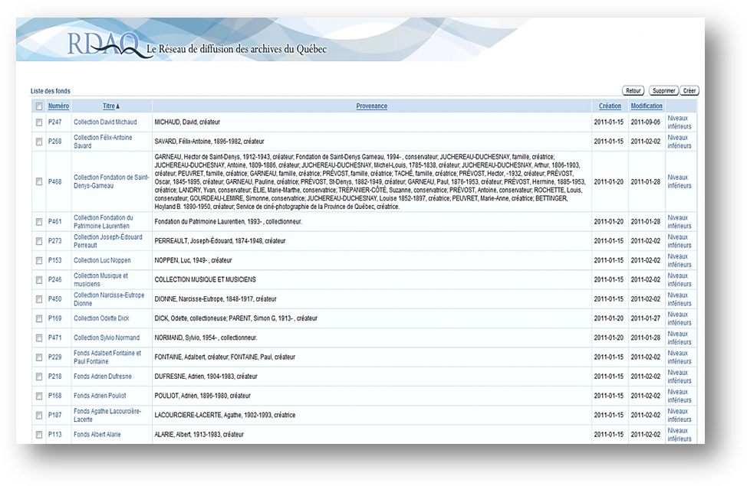
Initially, you will see only the first line, which indicates the fonds number, title, provenance, date of creation, date of modification and lower levels. Once you have created new descriptions of fonds or collections, you can sort your fonds by number, title or date by clicking on the corresponding words. Given that the Provenance zone can contain several names, as in the case of a large family, the number of characters that can be used for the purpose of sorting is limited.
To create a new fonds-level description, click on the Créer tab situated in the upper right corner of the screen.
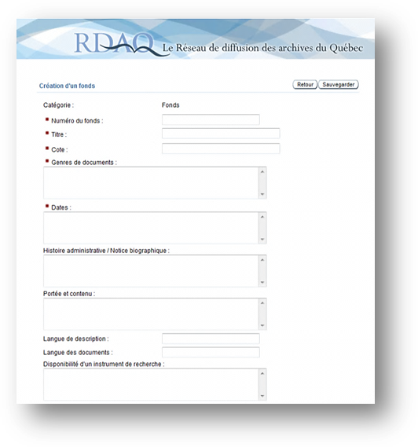
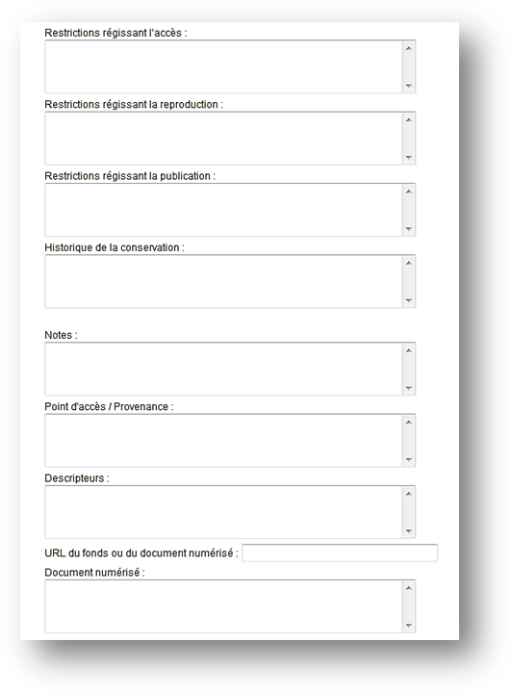
You will arrive at this page, which resembles a form the blanks of which must be filled in.
Note that blanks preceded by a red asterisk (*) must be filled in.
The fields are taken from Rules for Archival Description (RAD).
You may enter your information directly into the boxes or use the copy and paste technique from the descriptions already entered into your computer.
A handy trick if you use Word: first copy your text into the Windows Notepad programme in order to eliminate all undesirable marks then copy your text into the blanks of the form.

For those unfamiliar with RAD, the following information will help you to better understand the functions of the fields. We will take each field in turn and explain its function.
Note that the following is a simplified non-comprehensive explanation of certain elements of RAD and that you should consult the official publication, if you have questions, to obtain further explanations or to find examples. You can obtain a copy of RAD from the Website of the Canadian Council of Archives at: http://www.cdncouncilarchives.ca/RAD/RADComplete_July2008.pdf
References to the corresponding rules in RAD are provided at the end of the explanations.
Descriptive Unit: This refers to the level of description that you are documenting : fonds, series, sub-series, sub-sub-series, file, or item.
Fonds number: This refers to the reference number that you have given to your fonds or collection.
Title: The title of your fonds or collection, based on the creator of the documents. Examples : Fonds René Lévesque, Fonds Famille Meloche, Fonds Fédération des Harmonies du Québec, Fonds Joseph et Marie-Geneviève Drapeau. The title at lower levels (series, sub-series, file, item) is often based on the form of the material. Consult RAD to determine the best possible title. (RAD 1.1B)
Reference Number: The reference number of the unit you are describing (the reference number of the fonds, series, sub-series etc.) assigned by your archival service.
Types of documents : Specify the extent of the descriptive unit (e.g: 43 cm) and the material designation (e.g: textual records). When there are several classes of material, their designation proceeds in decreasing order of significance. (RAD 1.5B)
Dates : The inclusive dates of creation of the documents. Refer to the RAD rules to compose this extremely important element of the description. (RAD 1.4B)
Administrative history/biographical sketch: The administrative history is that of the corporate body responsible for the creation, accumulation, and/or use of the fonds. Here you relate the organization’s history, including, for example, the date of its foundation, its functions, and its administrative structure. The biographical sketch is used for individuals. It is a short notice which includes, for example, the place and date of birth, formal education, profession, honours received, and the place and date of death. (RAD 1.7B)
Scope and content: The scope for the unit you are describing explains its reseach interest. Bring out its significance for research, inform about the functions and activities that generated the records, about the period covered by the documents, the geographical area, etc. The scope often begins with The fonds shows, or reflects or documents… . The content part of the description announces the composition of the fonds. You can demonstrate the structure of the classification scheme, name the principal series, and present the types of documents constituting the unit being described (correspondance, minutes, architectural drawings, etc.). The content section often begins with The fonds contains, or includes, or consists of… . (RAD 1.7D)
Language of description: Note here the language in which you have written your description. This field is important, particularly when the description is added to the Archives Canada portal.
Language of documents: Record the language or languages of the documents in the unit being described. (RAD 1.8B14)
Availability of a finding aid: If a finding aid exists in your archival service for the fonds being described, record it in this field, whether it be a catalogue, an inventary, an index, a list, or any other type of research tool. (RAD 1.8B17)
Restrictions on access: Give information about any restrictions on access to the unit being described or to any part of it. (RAD 1.8B16a)
Restrictions governing reproduction: Give information on restrictions governing reproduction of documents, as imposed by legislation or by the donor. (RAD 1.8B16c)
Restrictions governing publication: Give information on restrictions that may affect publication of documents, as imposed by legislation or by the donor (copyright, patents, etc.). (RAD 1.8B16d)
Custodial history: This is the history of the fonds being described. From the moment of creation of the documents down to the present, give information on their successive transfers of ownership and custody, with dates if possible. (RAD 1.7C)
Notes: Use this area to provide any information of potential interest to researchers regarding your fonds or collection or the creator of the fonds or of the collection that cannot be fitted into other areas of the description. For example: related groups of records, complementary instalments, variations on the title, the source of a title, etc. (RAD 1.8)
Provenance access points: Indicate the family name or names of the creator or creators of the fonds followed by the given name or names . (RAD 21.2)
Descriptors: These are the index terms (key words) that facilitate research. (Part II of RAD)
URL of the fonds or digitized document: Add here the link to the address of the webpage containing the description if the descriptions by your archival centre are already posted on a website.
Digitized document: Add here a link to the address of the webpage where the digitized document appears if your archival centre has a digitized image relative to a description.

How to enter a lower-level description.
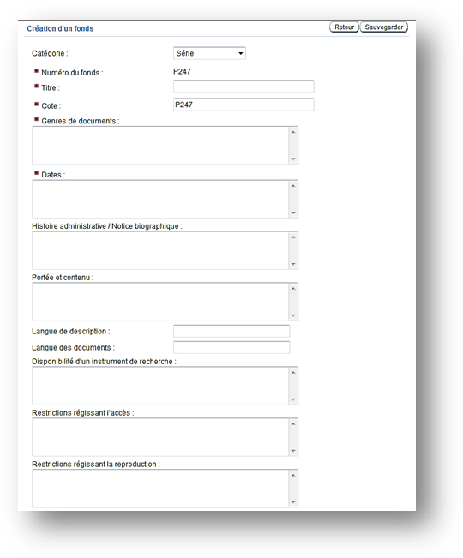
To create a lower level (e.g., a series in a fonds, or an item in a file), click on the administration link, Liste des fonds, then find the desired fonds and click on Niveaux inférieurs on the right.
You will arrive at the page containing the description of your fonds. Click on the button Ajouter un niveau inférieur and a window like that on the left will appear.
The same fields will appear as with the description of a fonds, with the exception of that for a descriptive unit. You can scroll down the descriptive units list which includes series, sub-series, sub-sub series, file, and item.
The description should match the level of description, that is enter into the various fields the same kinds of information as for the fonds, but only that information relative to the unit being described (series, sub-series, etc.)

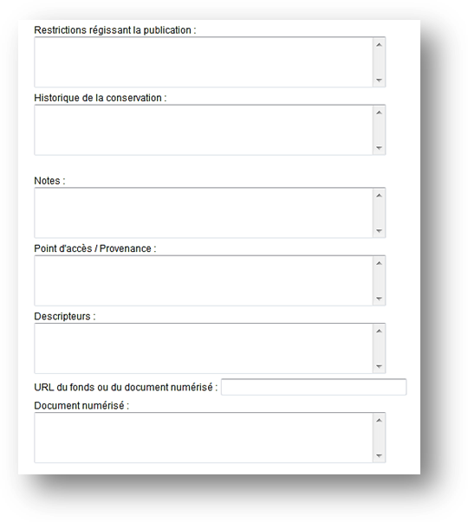
You can at any time see examples of fonds and lower-level descriptions by other organizations by conducting a search in the RDAQ database. On the homepage of the RDAQ site, click on Recherche sur les archives and search the database on the subject of your choice.
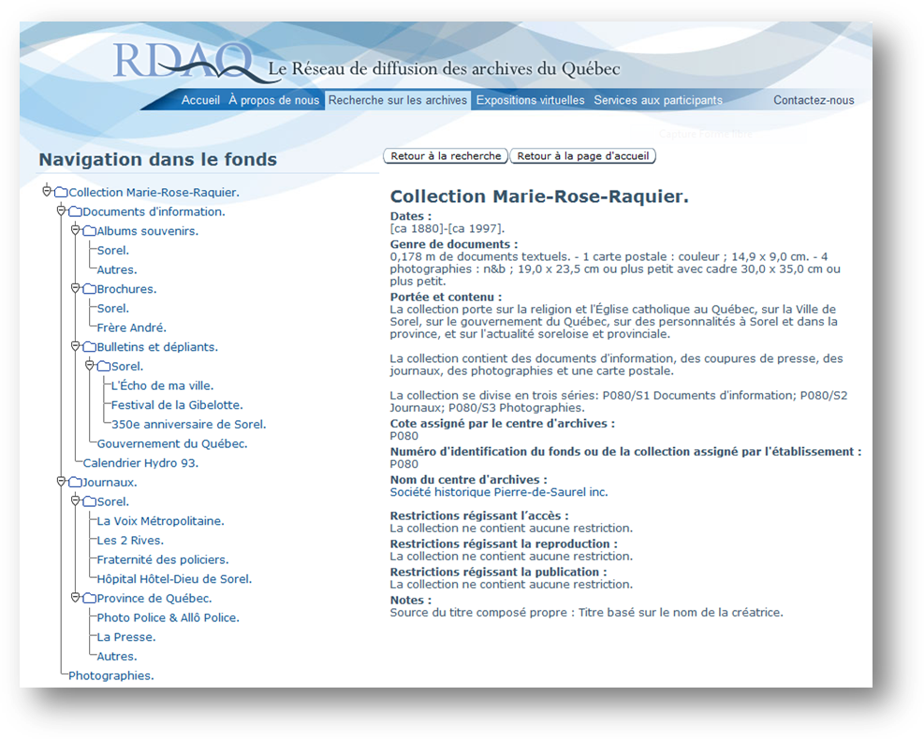
Here is an example of a search for an archival fonds:
To the left is the classification scheme of the fonds or of the collection with its levels. Click on the desired level to obtain the corresponding description on the right.

How to announce a virtual exhibition
To provide a link to a virtual exhibition, go to the RDAQ site. In the administration section, click on Expositions.
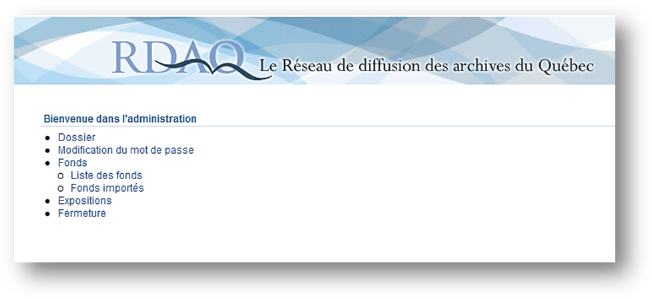
This page will appear, containing the list of exhibitions. Click on Créer to add an exhibition.
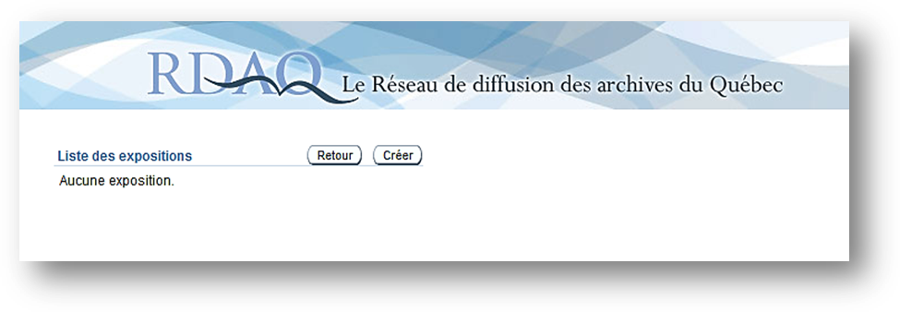

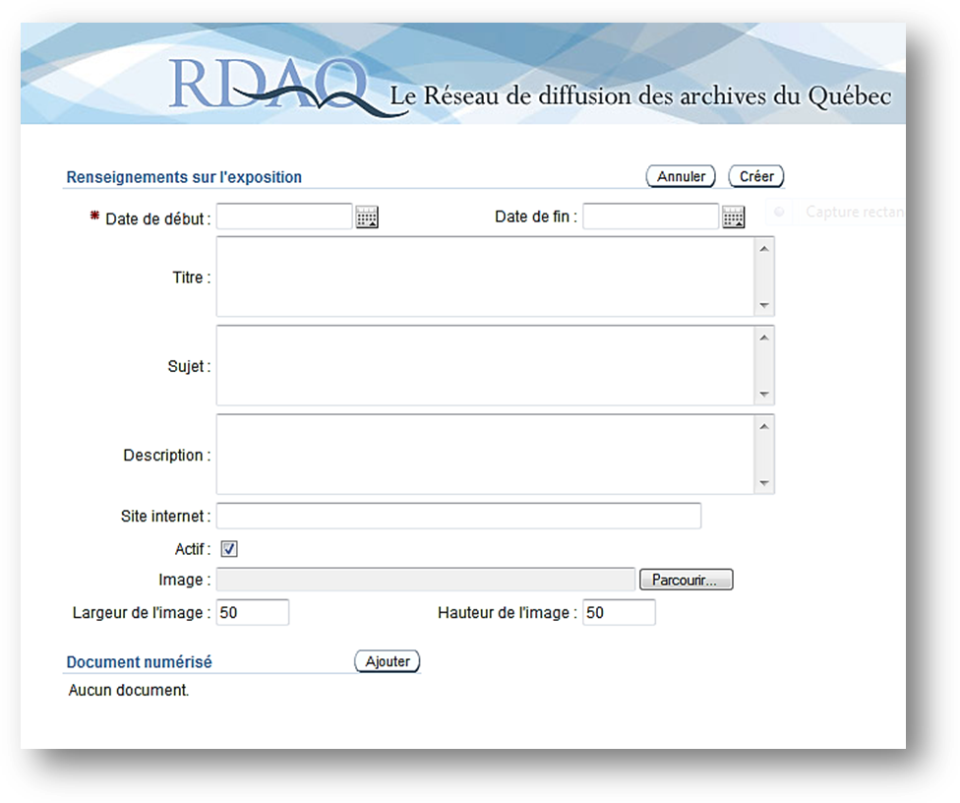
You can then enter the information on your virtual exhibition in the appropriate fields. Entering the starting date is obligatory.
The announcement of your virtual exhibition will appear in the list of virtual exhibitions on the RDAQ site at the Expositions virtuelles tab.

References:
Canadian Council of Archives. Rules for Archival Description (RAD). Ottawa, Bureau of Canadian Archivists, c1990, most recent revision, 2008.
Duff, Wendy M. and Marlene van Ballegooie. RAD Revealed : A Basic Primer to the Rules for Archival Description. Canadian Council of Archives, 2011, 144 p.
Réseau des services d’archives du Québec et Bibliothèque et Archives nationales du Québec. Réseau de diffusion des archives du Québec (RDAQ) [website] http://rdaq.banq.qc.ca/accueil/
Saulnier, Carole. Guide de l’usager du RDAQ. Réseau des services d’archives du Québec, 2003, 55 p.

Blanche Gagnon
Archives advisor
Réseau des services d’archives du Québec (RAQ)
archiviste.conseil.raq@gmail.com
Octobre 2011

Translation James H. Lambert
November 2015

